Mid-Year Benchmark
2015-2016 7th Grade Science

- Which component of the atmosphere is most variable on a daily basis?
- Argon
- Oxygen
- Water vapor
- Nitrogen
2. What do the troposphere and the mesosphere have in common?
A. They both contain the largest number of air molecules in the Earth’s atmosphere.
B. Satellites orbit in both of these atmospheric layers.
C. They both decrease in temperature as the altitude increases.
D. They both increase in temperature as the altitude increases.

3. 78% of Earth’s atmosphere is made up of this gas.
A. Nitrogen
B. Oxygen
C. Argon
D. Carbon Dioxide

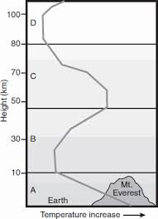
4. This picture illustrates the four major layers of the Earth’s atmosphere. Which layer is represented by letter B on the diagram?
A. Thermosphere
B. Stratosphere
C. Troposphere
D. Mesophere

- Which two layers of the atmosphere experience a decrease in temperature with height?

- Thermosphere and stratosphere
- Stratosphere and mesosphere
- Mesosphere and troposphere
- Troposphere and thermosphere

- Paving a large parking lot would most greatly affect which part of the water cycle?

- Condensation
- Precipitation
- Surface runoff
- Evaporation

7. Over 6 billion people use water on the Earth every day, yet Earth’s supply of water remains fairly constant. This is because
A. the sea level is rising.
B. water exists in three phases on the Earth.
C. global warming melts ice to replace the water we use.
D. water is constantly recycled through the water cycle

8. The diagram below shows four stages of the water cycle.
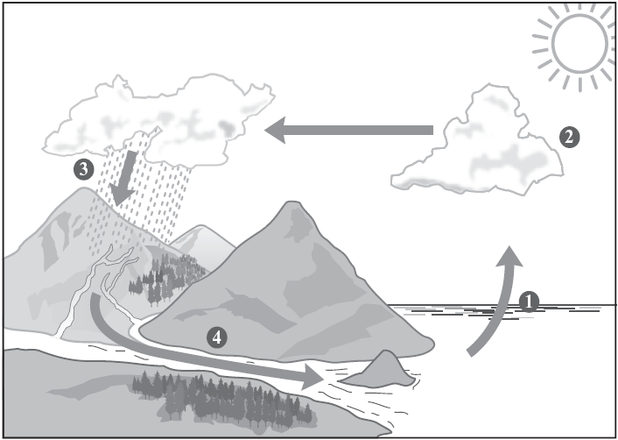
Which change is occurring at stage 1 in the diagram?
 | A. | Water is changing from a gas to a solid.
 | B. | Water is changing from a liquid to a gas.
 | C. | Water is changing from a liquid to a solid.
 | D. | Water is changing from a solid to a liquid.

- What process is most closely associated with cloud formation?

- Evaporation
- Sublimation
- Condensation
- Precipitation

- What is the primary cause of wind?

- Differences in air pressure
- Cloud formation
- Falling precipitation
- Tree movement

- The map below shows the location of a low pressure system on a day in November. What change in the weather conditions is most likely for central North Carolina?

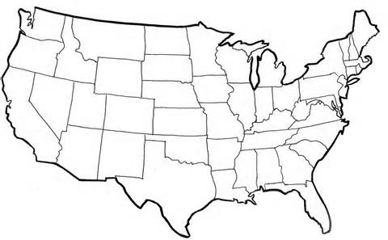
L

- Temperatures will be warmer than average with northeasterly winds
- Temperatures will be warmer than average with southwesterly winds
- Temperatures will be colder than average with northwesterly winds
- Temperatures will be colder than average with southeasterly winds

12. Which of the following factors would most likely cause a hurricane to decrease in strength?
A. staying over warm water for a long period of time
B. moving over land on a continent
C. moving towards tropical waters
D. increasing the number of large cumulonimbus clouds

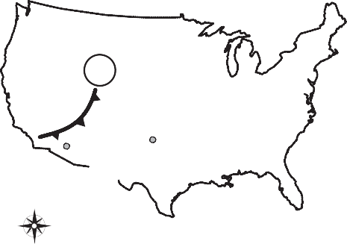
13.
L
Phoenix, Arizona 90°F
Amarillo, Texas 95°F
N

W E

S
Tuesday

Which of these describes the weather change that can be expected for Amarillo, Texas?
- The cold front will bring cooler temperatures and snow.
- The cold front will bring cooler temperatures with thunderstorms and rain.
- The warm front will bring warmer temperatures with hot air for several days.
- The warm front will bring warmer temperatures with light rain for a few days.

- Light drizzle and an increase in air temperature are most closely associated with which type of front?

A. Occluded
B. Stationary
C. Cold
D. Warm
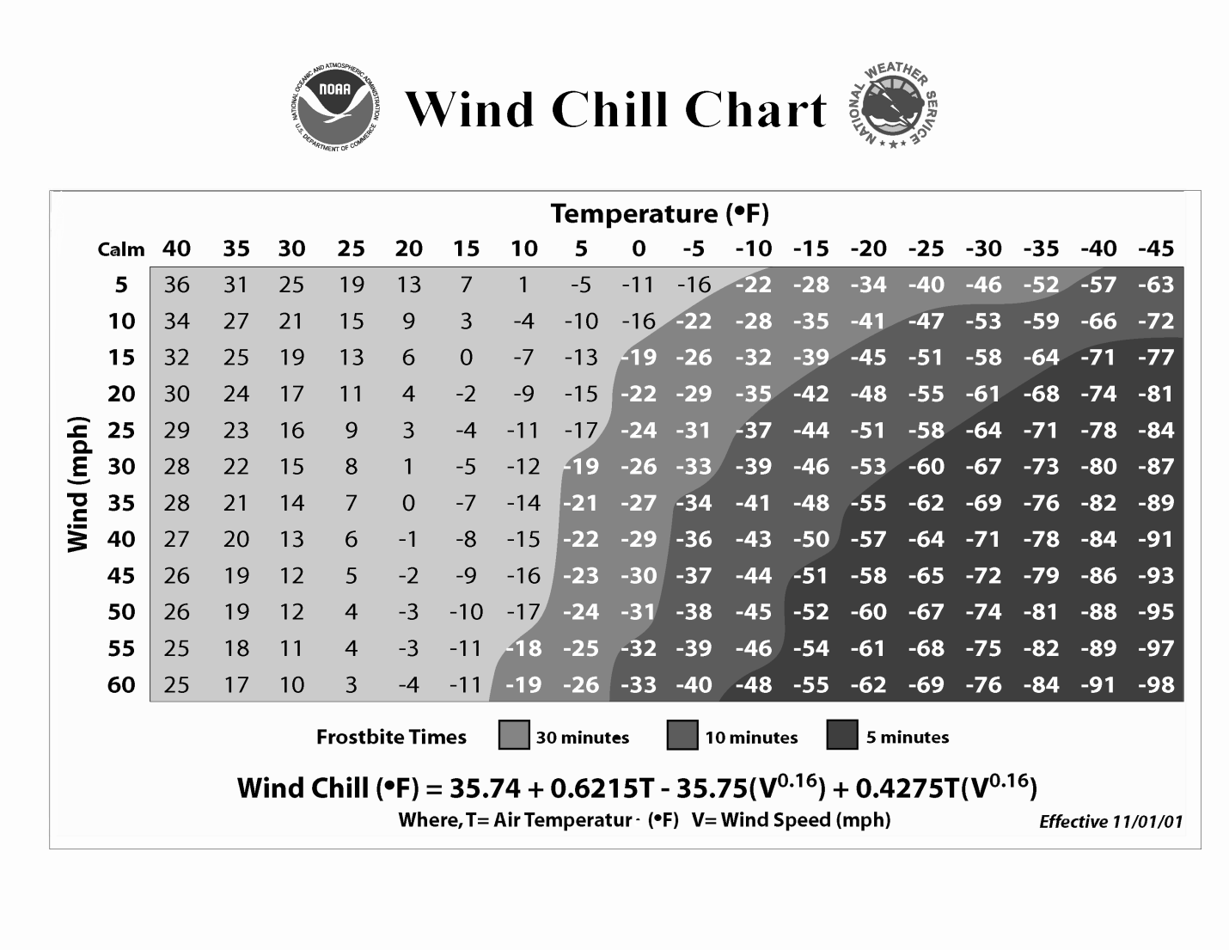
- According to the chart above, what is the wind chill temperature when the air temperature is 15ºF and the wind speed is 30 mph?
- -17 ºF
- -5 ºF
- 2 ºF
- 19 ºF
- What wind direction is most likely to bring cold, dry air to North Carolina?
A. Northeast
B. Northwest
C. Southeast
D. Southwest

17. The weather forecaster predicts that a snowstorm is coming later in the day. Which weather observation best supports this prediction?
A. Dark nimbostratus clouds
B. Thin, wispy cirrus clouds
C. Fair weather and blue skies
D. Freezing temperatures

18. Which tool is least helpful in predicting weather?
A. barometer
B. thermometer
C. rain gauge
D. anemometer

- Letters on the map are used to indicate general regions of the United States.
W
Y
X
Z
Based on the general patterns of weather systems, what statement best predicts the movement of a storm system?

- A system located at Z will generally move toward W
- A system located at W will generally move toward Z
- A system located at Y will generally move toward X
- A system located at Y will generally move toward W

- What influence does the Coriolis force have on pressure gradient wind direction in the Northern Hemisphere?

- Pushes wind to the left
- Pushes wind to the right
- Pushes wind up
- Pushes wind backwards

- What is the primary energy source that drives all weather, including precipitation,
hurricanes, and tornadoes?
A. Earth’s gravity
B. the Sun
C. Earth’s rotation
D. the Moon’s orbit
- The map below shows the location of the Gulf Stream, an ocean current that moves tropical water along the east coast of the United States.
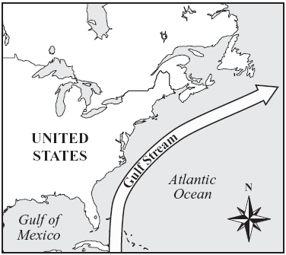

Which of the following statements best describes how the Gulf Stream affects the weather along the east coast?
- It makes the air less humid and brings less rain to the area.
- It makes the air temperature cooler and the winds stronger.
- It makes the winds stronger and brings less rain to the area.
- It makes the air temperature warmer and the air more humid.
- What human activity can have the greatest positive effect on global climate change by helping to reduce the amount of carbon dioxide in the air?
A. removing trees to build houses
B. recycling plastics to manufacture materials
C. increasing the number of electric motors in cars
D. using alternatives to CFCs in refrigeration

- The picture below shows a place where air currents will form due to the uneven heating of Earth.

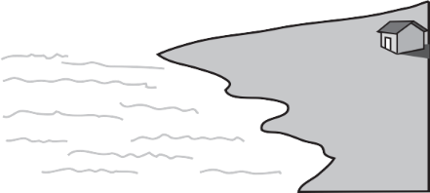

In which direction will air currents most likely move?
- straight down over the land
- from the land toward the sea
- straight up above the sea
- from the sea toward the land

25. As a consequence of global warming, coastal areas could
A. be flooded as ocean levels rise
B. become further inland as ocean levels recede
C. become cooler due to more water in the water cycle
D. sink as the land becomes less stable

26. A weather satellite can take a picture of a hurricane from space and send it to the Earth in
seconds. How would the people of North Carolina benefit from receiving a picture so quickly?
A. The picture can show the direction of the hurricane
B. People will know how long the hurricane will last
C. The picture will show the intensity of the hurricane
D. People can be warned about the approaching hurricane

27. A winter storm warning has been issued for your area. What is the most important step to take next?

- Purchase a snow shovel and sidewalk salt
- Turn up the heat in your house
- Locate your gloves and boots
- Gather a supply of water and non-perishable food

28. A scientist is trying to track the movement of a rocket. What information does the scientist need to determine the velocity of the rocket?
A. the mass and speed of the rocket
B. the speed of the rocket and the direction the rocket is moving
C. the mass and the time the rocket has been traveling
D. the time the rocket has been moving and the speed of the rocket

29. A car and a truck move on a road in the same direction at the same speed. Both vehicles slow down with the same stopping force.

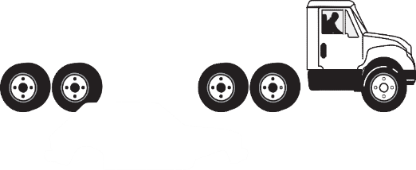
Which statement best explains why the truck needs more distance to stop?
- The truck is longer.
- The truck has more mass.
- The truck has larger wheels.
- The truck has a larger engine.

- A scientist is trying to track the movement of a rocket. What information does the scientist need to determine the velocity of the rocket?
A. the mass and speed of the rocket
B. the speed of the rocket and the direction the rocket is moving
C. the mass and the time the rocket has been traveling
D. the time the rocket has been moving and the speed of the rocket

- Four students push on a block of wood with the forces shown in the diagram
below. Assume friction is zero.

Block
10 N
8 N
5 N
2 N
The block slides horizontally. What is the net force acting on the block of wood?

- 3 N to the left
- 8 N to the left
- 11 N to the right
- 25 N to the right
32. Jerry dropped a feather and marble from the same height during a lab in his science classroom. What do you expect to happen?
A. the feather reached the ground first because it had less mass than the marble.
B. the feather reached the ground last because air pushed up on the feather.
C. the marble reached the ground first because it had more mass than the feather.
D. Newton’s 2nd law says that the feather and the marble would land at the same time.

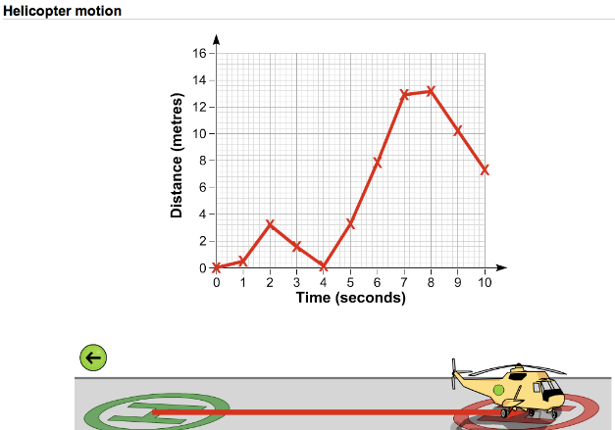

33. During what period of the helicoptor’s motion was it experiencing the greatest speed?
- 0-2 seconds
- 3-4 seconds
- 5-7 seconds
- 8-10 seconds

34. Use the graphs below to answer the question: What do these graphs have in common?

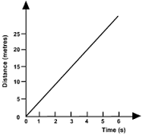

A. They both represent objects at a constant velocity.
B. They both represent objects that are increasing speed.
C. They both represent objects that are decreasing speed.
D. They both represent objects that are at rest.
35. An object moves away from a motion detector with a constant speed. Which graph best represents the motion of the object?
A.
time
distance

B.
time
distance

C.
time

distance

D.
time
distance

36. Which of the following increases when a rubber band is stretched?
A. electrical energy
B. mechanical energy
C. kinetic energy
D. potential energy
37. A bicycle rider ate breakfast before he went on a 10 mile ride. Which of the following energy
transformations were used during this bicycle ride?
- Kinetic energy to potential energy C. Kinetic energy to nuclear energy
- Chemical energy to kinetic energy D. Chemical energy to potential energy

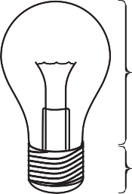
38.
TOP

BOTTOM

The bottom of this light bulb is an example of what type of simple machine?
- a lever
- a pulley
- a screw
- a wedge

39. Often, the only way to get a large piano into a house or apartment is to lift it through a window. Piano movers use heavy ropes attached to a simple machine on the back of their delivery truck to get the piano into the house. What kind of simple machine do they most likely use?

- Lever B. Pulley C. Inclined plane D. Wedge

40. Two workers use a ramp to help lift a box onto a dock as shown below. Use the diagram the following question.

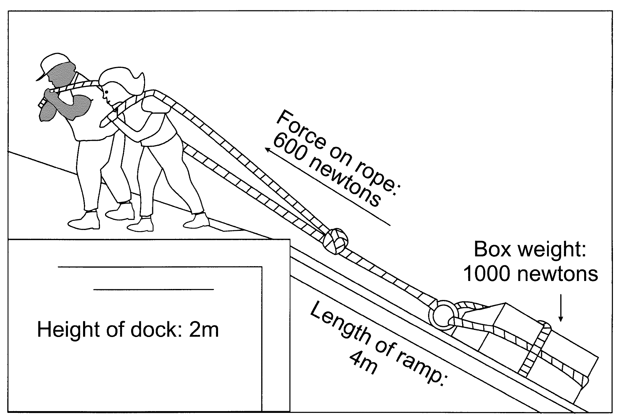
Despite the advantage gained by using the ramp, there is a loss of energy mainly due to
- friction between the box and the ramp.
- the length of the ramp.
- the rope stretching when it is pulled.
- two people pulling the rope.

