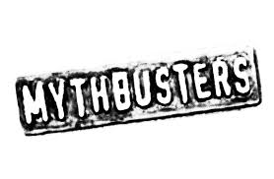Name: ________________________________ Core: ________ Date: _____________
Episode Title: __________________________________________

1. What warnings do they give to viewers at the beginning of the show?

2. What myth or legend are they investigating? Pick one if there are more than one in the episode.

3. What did they know before they began investigating?

4. What did they do to investigate the myth/legend?

5. What did they learn? Confirmed, busted or plausible? Why?

6. Identify any controls and variables involved in the investigation (at least one each)

7. What are the safety measures they used to prevent accidents/injuries?

8. Are their results reliable? Explain.

