My Journey as a Water Molecule
You are a single water molecule. Write a story about your journey through the entire water cycle as a water molecule. You MUST include the 6 steps to the water cycle: evaporation, condensation, precipitation, transpiration, runoff, and infiltration (in ANY order you choose!)
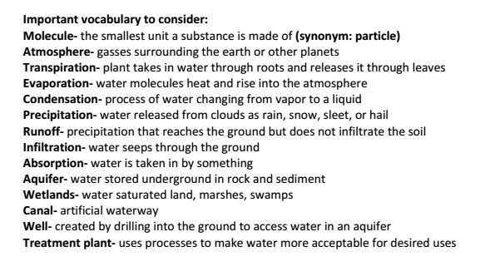

My Journey as a Water Molecule
You are a single water molecule. Write a story about your journey through the entire water cycle as a water molecule. You MUST include the 6 steps to the water cycle: evaporation, condensation, precipitation, transpiration, runoff, and infiltration (in ANY order you choose!)

