Cloud Selfies! X Three!
You will use a device to take THREE pictures of yourself with DIFFERENT clouds you find in the sky.
1. Take THREE selfies with a cloud—you have to be in the picture!
Cirrus Nimbostratus
Cirrocumulus Stratus
Cirrostratus Cumulus
Altocumulus Cumulonimbus
Altostratus
2. Include the following for ALL THREE clouds:
a. Name of the cloud
b. Description of the cloud
c. Is it a high level, middle level, low level or multi-level cloud?
d. What kind of weather did you notice on the day you took the picture? What weather is associated with this type of cloud?
3. The entire assignment can be uploaded to Google Classroom or you can print everything and turn it in. Descriptions need to be typed up in a word document and pictures also need to be inserted into the word document. The layout should look something like this:
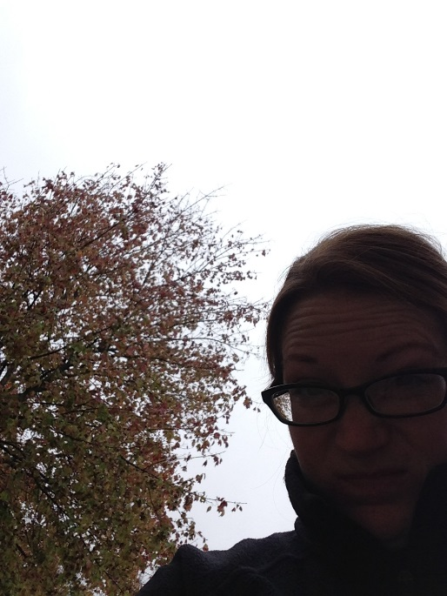
Due: Wednesday, November 30th
Cloud Selfie #1
Description:
a. Name of the cloud
b. Description of the cloud
c. High, middle, low or multi-level cloud?
d. Weather associated with this cloud?

